**The Fascinating History of Netflix**

[interestingengineering.com](https://interestingengineering.com/the-fascinating-history-of-netflix)

Christopher McFadden

18-23 minutes

For millions, [Netflix](https://interestingengineering.com/why-is-hbo-still-ahead-of-netflix-and-hulu) is the *de-facto* place to go for movie and TV streaming. According to sites like [fortune.com](https://fortune.com/2018/10/02/netflix-consumes-15-percent-of-global-internet-bandwidth/), its services alone constitute about **15%** of all the world's internet bandwidth!

Not bad for a company that started by posting DVDs by snail mail. Here we explore the origins of the company and track some of the important milestones in history.

[**RELATED: HOW EXACTLY DOES NETFLIX RECOMMEND MOVIES TO YOU?**](https://interestingengineering.com/how-exactly-does-netflix-recommend-movies-to-you)

**Who started Netflix?**

[Netflix](https://media.netflix.com/en/management-team) was first founded in August of 1997 by two serial entrepreneurs, Marc Randolph and Reed Hastings. The company began out in Scotts Valley, California, and has grown to become one of the world's leading internet entertainment platforms.

When it first opened, [Netflix](https://interestingengineering.com/netflix-stirs-controversy-by-calling-out-53-users-whove-watched-a-film-repeatedly) was purely a movie rental service. Users ordered movies on the Netflix website, and received DVDs in the post. When they were finished with them, they would simply post them back to[Netflix](https://interestingengineering.com/netflix-miniseries-the-mind-explained-explores-the-fascinating-science-of-the-brain) in the envelopes provided. At the time, this was seen as a boon to those who did not have a video rental store nearby (remember those?).

Today, Netflix streams movies and has more than**151 million** paid subscribers in over **190 countries** around the world. It offers a wide range of TV series, documentaries, and feature films across a wide variety of genres and languages, including original productions.

**Reed Hastings helped cofound Netflix back in the 90s**

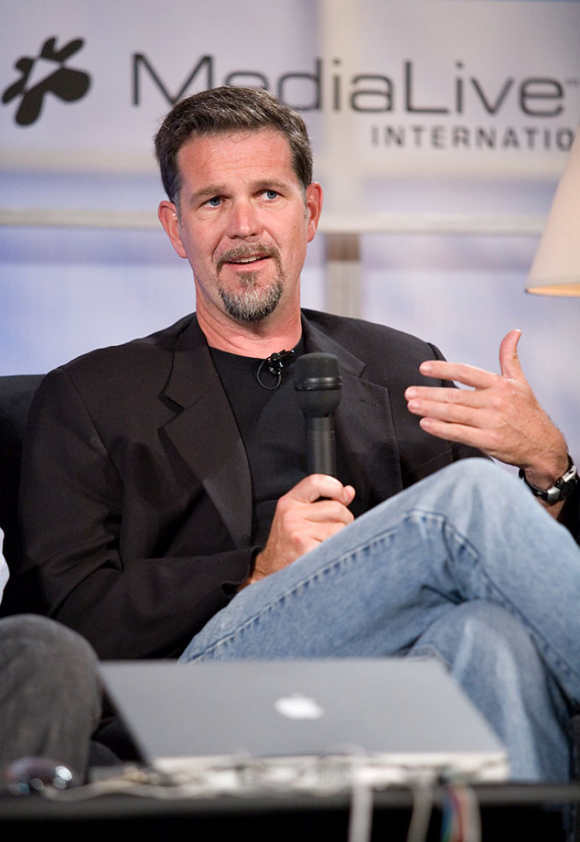*Source:* [*Guety/Wikimedia Commons*](https://commons.wikimedia.org/wiki/File:Reed_Hastings,_Web_2.0_Conference.jpg)

[Reed Hastings](https://www.forbes.com/profile/reed-hastings/#2f0c62ec2782) co-founded Netflix in 1997. He was an entrepreneur who in 1991 had founded Pure Software, which made tools for software developers. After a 1995 IPO and several acquisitions, Pure was acquired by [Rational Software](https://www.bloomberg.com/profile/company/RATL:US) in 1997.

Hastings received a BA from Bowdoin College in 1983 and an MSCS in [artificial intelligence](https://interestingengineering.com/ai) from Stanford University in 1988. Between Bowdoin and Stanford, he served in the Peace Corps as a high school math teacher in Swaziland. Today, he is an active educational philanthropist, having served on the California State Board of Education and on the board of several educational organizations.

**Marc Randolph is the other chap behind Netflix**

*Source:*[*marcrandolph.com*](https://www.marcrandolph.com/about/)

[Marc Randolph](https://www.forbes.com/sites/hayleycuccinello/2019/09/17/netflix-cofounder-marc-randolph-memoir/#1d0ff2d07da9) is a veteran Silicon Valley entrepreneur, advisor, and investor. As co-founder and founding CEO of Netflix, he laid much of the groundwork for a service that’s grown to **150 million** subscribers and fundamentally altered how the world experiences media.

He also served on the Netflix board of directors until retiring from the company in 2003." - [marcrandolph.com](https://www.marcrandolph.com/about/).

Randolph graduated from university with a degree in Geology and would go on to found and run various mail-order and direct-to-customer companies before Netflix.

Throughout Randolph's career, he founded no fewer than six successful startups, including the [magazine Macworld](https://www.macworld.com/), and has mentored hundreds of early-stage entrepreneurs.

**When and where was Netflix founded?**

As previously mentioned, [Netflix](https://www.britannica.com/topic/Netflix-Inc) was founded in 1997 in Scotts Valley, California. It was originally a rent-by-mail DVD service that used a pay-per-rental model.

Users would browse and order the films they wanted on their website, put in an order, and Netflix would post them to your door. After renters had finished with the DVDs, they would simply post them back.

Rentals cost around **$4** each, plus a **$2** postage charge. After significant growth, Netflix switched to a subscriber-based model.

With this model, users could keep the DVDs for as long as they liked, but could only rent a new movie after returning their existing one.

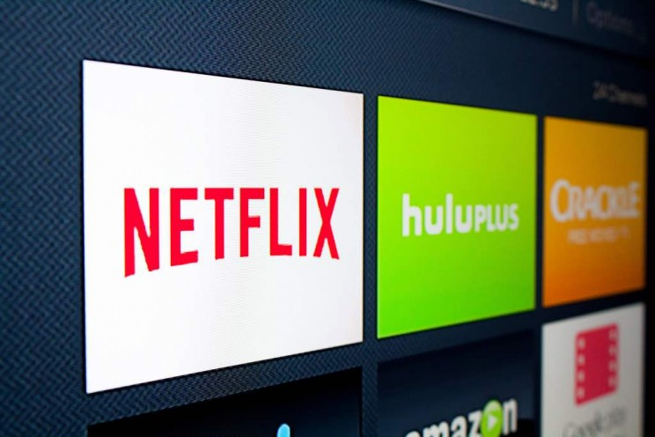*Source:*[*Matthew Keys/Flickr*](https://www.flickr.com/photos/matthewkeys/19338701712)

Netflix's mail-order rental model would directly challenge the market dominance of bricks-and-mortar rental giants like [Blockbuster](https://en.wikipedia.org/wiki/Blockbuster_LLC). In fact, Blockbuster could ultimately not compete with the move to online streaming and rentals and filed for [bankruptcy in 2010](https://www.forbes.com/sites/gregsatell/2014/09/05/a-look-back-at-why-blockbuster-really-failed-and-why-it-didnt-have-to/).

But this never needed to happen. Years earlier, Blockbuster had the opportunity to partner with Netflix, or even buy the company out.

"In 2000, Netflix CEO and co-founder Reed Hastings approached[Blockbuster](http://www.blockbuster.com/)about a partnership. Unfortunately for Blockbuster, their CEO just smiled and laughed at him.

In fact, Blockbuster even had a chance to purchase Netflix for **$50 million**. Netflix currently has a [Market Cap of**[$209.74B]**](https://ycharts.com/companies/NFLX/market_cap) (July 2020) and a share price of  **$476.89,** while Blockbuster is out of business." - [rewindandcapture.com.](https://www.rewindandcapture.com/why-is-it-called-netflix/)

**Why is Netflix called Netflix?**

You could probably work this one out for yourself. But in case you are still stumped, the name Netflix is a combination of "Net" (as in the abbreviation for "internet" and "Flix" (a variation of "flick", the common abbreviation for a movie or film).

Pretty straight forward really.

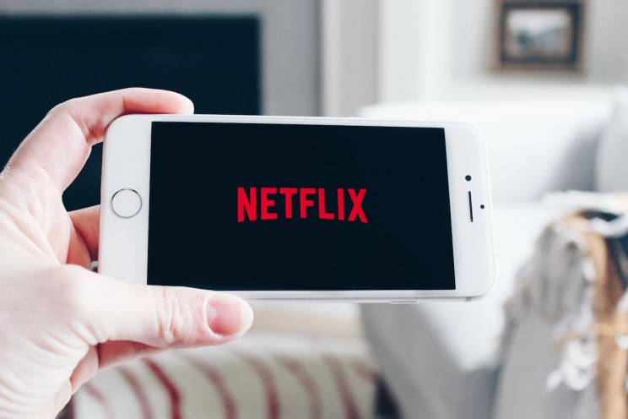*Source:*[*Stock Catalog/Flickr*](https://www.flickr.com/photos/stockcatalog/40970937195/in/photolist-25qsLdT-tNH4P-9dV6h9-hjVFk7-53xZNB-H929tx-enTcF-24m3o2-2bSm2fr-2dbsEeA-9pmoxi-3mvm1Y-62vaeJ-8NSauQ-7tXu7L-98qSsb-5DeoW6-7NuHd7-Bufki-auRimi-dfQSJ3-qQbzL-ejDkB7-aHs1D4-9ubtHi-2ffEqGw-7Aq39p-TUzhD6-Hs9sq-Hs9su-24Hi45F-6KH7A2-HsgNP-7yauEX-5XZ3To-7hiJ13-8N5xwY-7yekHj-5ydfq7-aHs1Ex-VDsHKZ-6YhEXE-2c9ELg4-odGJzr-5ydfeA-awabqC-5nxoi9-Hs9so-9FUULy-Azj3X)

**How was Netflix founded?**

At the time Netflix was founded, Randolph was working as a [marketing director](https://www.ziprecruiter.com/e/What-Does-a-Marketing-Director-Do) for Hasting's company Pure Atria. He was also the co-founder of MicroWarehouse (a computer mail-order company).

Hasting would later sell Pure Atria to the Rational Software Corporation in 1997 for **$700 million**.

By all accounts, the [pair came up with the idea for Netflix](https://www.nytimes.com/2019/09/15/business/media/netflix-chief-executive-reed-hastings-marc-randolph.html) during a commute between their homes in Santa Cruz and Pure Atria's HQ in Sunnyvale.

Hastings would supply the seed capital, and invested **$2.5 million** into the startup in cash. Inspired by [Amazon's e-commerce model](https://smallbusiness.chron.com/description-amazon-uses-ebusiness-ecommerce-b2b-b2c-36453.html), the pair explored various portable items they could use to sell over the internet in a similar fashion.

After initially considering and rejecting VHS cassettes, they settled on DVDs as the perfect product. They tested their idea by posting a DVD to their homes in Santa Cruz, and when it arrived in perfect condition, they decided the time was right to break into the market with their revolutionary model.

Netflix launched in April of 1998 as one of the world's first online DVD rental companies. They had only a few staff, and just under 1000 titles at the time.

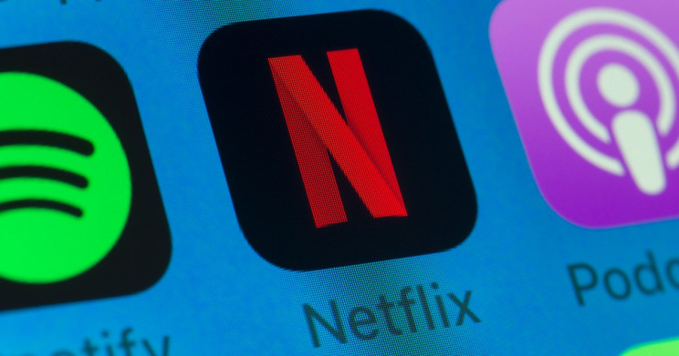*Source: [stockcam/iStock](https://www.istockphoto.com/en/foto/netflix-spotify-podcasts-und-andere-handy-apps-auf-dem-iphone-bildschirm-gm1065121660-284812543" \t "_blank)*

**Some of the key milestones in Netflix's history**

Here is a brief timeline of some of the critical milestones in the company's history (courtesy, in part, of [Netflix.com](https://media.netflix.com/en/about-netflix)):-

**It all kicks off 1997**

Reed Hastings and [software](https://interestingengineering.com/apps-software) executive Marc Randolph co-found Netflix to offer online movie rentals.

**Netflix launches its DVD rental and sales service in 1998**

Netflix launches the first DVD rental and sales site, Netflix.com.

**Their subscriber-based business model launches in 1999**

Netflix debuts a subscription service, offering unlimited DVD rentals for one low monthly price.

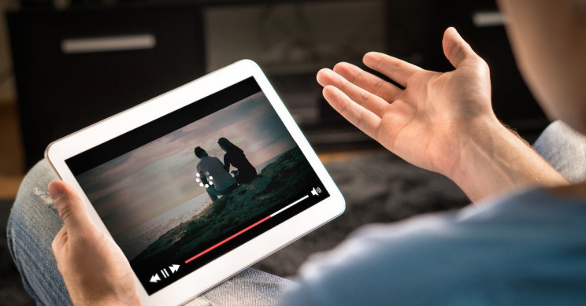*Source:* [*Tero Vesalainen/iStock*](https://www.istockphoto.com/de/en/photo/loading-icon-rolling-on-video-in-an-online-movie-streaming-service-gm873384592-243907973)

**2000 unveils subscriber personalization**

Netflix introduces a personalized movie recommendation system, which uses members’ ratings to predict choices for all Netflix members.

**Netflix goes public in 2002**

With a membership count at **600,000** in the US, Netflix makes its initial public offering (on the Nasdaq, under the ticker “NFLX”). The stock is initially offered for **$15** a share, with an initial offering of **5,500,000** shares.

The company ends the year with around **857,000** registered Netflix accounts.

Since then, Netflix has consistently been one of the [best-performing stocks in the S&P 500](https://www.investopedia.com/articles/active-trading/081315/if-you-invested-right-after-netflixs-ipo.asp#:~:text=Netflix%20went%20public%20on%20May%2023%2C%202002%2C%20with%20an%20initial,500%20from%202010%20through%202019.).

**The company celebrates 1 million accounts in 2003**

This year, Netflix hits a new record for the number of members, with more than **1 million**. The company also issues a patent with the U.S. Patent and Trademark Office for its subscription rental service, with some other extensions.

Co-founder Marc Randolph steps down as a member of the board and leaves Netflix in 2003.

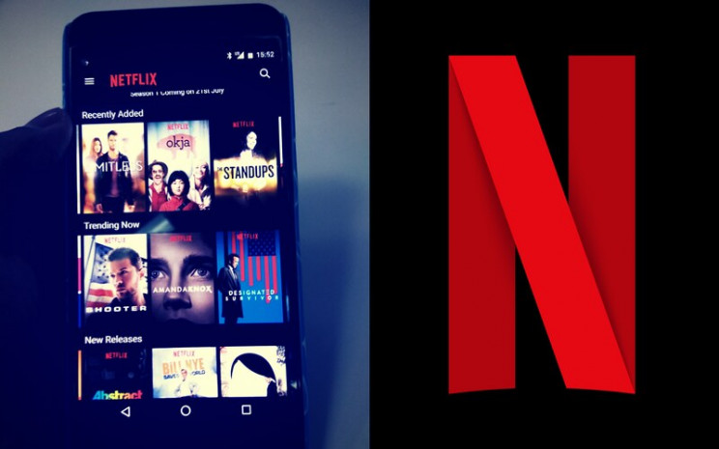*Source:* [*Dominic Smith/Flickr*](https://www.flickr.com/photos/cerillion/35210832443)

**2004 sees a doubling in the number of Netflix accounts**

This year, Netflix's member base surpasses **2 million.**At the same time, Netflix also faces one of its first encounters with the legal system when they are sued for false advertising in relation to claims of "unlimited rentals" with "one-day delivery".

The [claimant accused Netflix](https://arstechnica.com/uncategorized/2005/11/5515-2/) of failing to deliver on these two marketing promises in the San Fransisco Superior Court, claiming that the company's 3 at-a-time plan precluded unlimited rentals, and there was no way to ensure the one-day delivery using "snail mail".

Netflix denied any wrongdoing, and both parties eventually agreed on a settlement.

**By 2005, Netflix has doubled its subscriber base again**

The number of Netflix members rises to **4.2 million**.

**Netflix accounts hit a record 5 million in 2006**

Netflix sees huge growth in member numbers, reaching 6,3 million subscribers by years' end. The company also launches its "[Netflix Prize](https://www.thrillist.com/entertainment/nation/the-netflix-prize)", promising a whopping **$1 million** to the first person, or team, who can achieve a set accuracy goal in recommending movies based on personal preferences.

Netflix also released around **100 million** anonymous movie ratings, using a system that rates films from one to five stars. This is the largest set of such data released to date.

**Video streaming is introduced in 2007**

Netflix introduced a streaming service, called "Watch Now", which allows members to instantly watch television shows and movies on their personal computers. This was a huge shift in the company's business model. Initially, the service launched with [just 1,000 titles](https://www.thrillist.com/entertainment/nation/netflix-streaming-history-anniversary-watch-instantly) and only worked on PCs and Internet Explorer. It also offered a limit on the number of hours of free streaming (with a maximum of 18 free hours a month), based on the users' subscription plan.

Netflix was also careful to say that they felt DVDs would be around for a long time. Despite these limitations, it was soon clear that streaming was the future of entertainment.

By the end of 2007, Netflix had **7.5 million** registered subscribers -- up almost **20%** on the previous year.

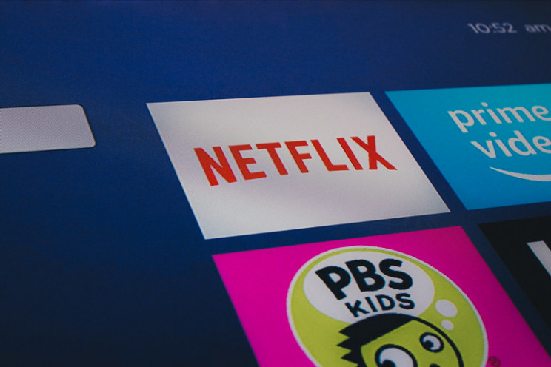*Source:* [*Stock Catalog/Flickr*](https://www.flickr.com/photos/stockcatalog/41826736992/in/photolist-26J5XFN-gwwP6-GvGt4-4xSAuN-4LvM1C-9RLct3-eCZ7JC-3muNsx-TUzhD6-8FFrBp-23XGHFv-9cFmNT-enTcF-2tzYCH-2h7EBdE-7Jwswh-38CXVF-38CYnP-4gx9cD-38CWUc-38Hwrw-Akrjs-ha9JX-5To2Lj-dVzGx3-hso5e-7dxJ8k-6YJhDH-5UsZgf-BymrSb-hso5g-hsmrd-dz5b62-9DGorK-7n5v48-7iPrST-24m3o2-4YfTsS-VDsHKZ-243aDNs-2iXWLQ1-74R6y5-Luodqo-CzNPJs-24m3oZ-7pCcqg-2a3TCG-7yekZL-62vaeJ-7vRHoA)

**Netflix teams up with various consumer electronics companies in 2008**

Netflix partners with [consumer electronics](https://interestingengineering.com/electronics) companies to allow streaming on the Xbox 360, Blu-ray disc players, and TV set-top boxes.

The year ends with around **9.4 million** subscribers.

**Netflix is added to Playstation and smart-TVs in 2009**

Netflix partners with yet more consumer electronics companies to allow streaming on PS3, Internet-connected TVs, and other Internet-connected devices. Its member base also expands to an amazing **12 million** accounts by the end of the year.

The "Netflix Prize" also finds a winner this year. "[Bellkor's Pragmatic Chaos](https://www.netflixprize.com/" \t "_blank)" team, consisting of seven researchers from four countries. Running for over three years, the contest had attracted **tens of thousands** of contestants from more than **180 countries** worldwide.

**Netflix connects to Apple devices and expands into Canada in 2010**

Netflix is available on the Apple iPad, iPhone and iPod Touch, the Nintendo Wii, and other [Internet](https://interestingengineering.com/internet)-connected devices at this point. Netflix launches its service in Canada.

The year ends with more than **20 million subscribers** on the books. This year also marked the point where the number of customers who were primarily streaming shows, outpaced those who were renting, leading Hasting to declare in an October earnings call that, "By every measure, we are now primarily a streaming company that also offers DVD-by-mail."

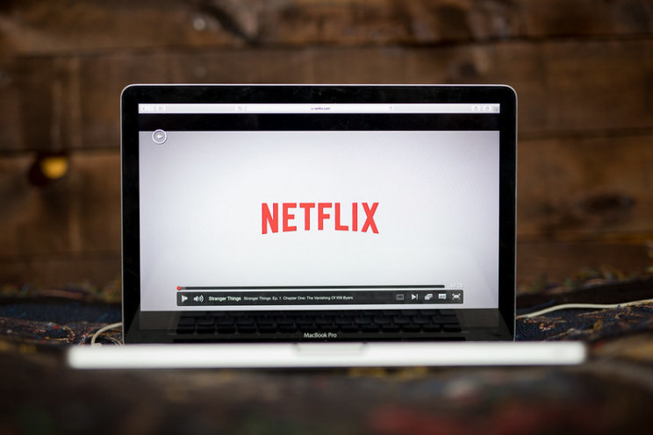*Source:* [*Stock Catalog/Flickr*](https://www.flickr.com/photos/stockcatalog/39609684685/in/photolist-25qsE3g-25qsJUv-H92fN6-23maZh2-H924JT-H9254F-pQzsW-4kZKsY-CwdNy-z8XBp-3ebj5L-fyxtiP-7QvH7x-7chCMD-4eFksc-Y6hF4-3226qA-53Cefq-25qsLdT-enTcZ-941S4q-23CyKEu-2iC49yn-arYEFW-5DHJQT-26J5X2S-5G2bys-243aF1h-2mAv1z-9dV6h9-2bSm2fr-2dbsEeA-9HKJ46-F4eKPK-H925nr-26J5YTh-25qsEmn-tNH4P-4c2ZsU-4JghA8-243aADb-nmTGcA-peawCw-64HWdo-35QVWT-39q165-24DyMSE-7e1gyx-54d95X-hso5i)

**The Qwikster debacle of 2011**

Buoyed by the success of its streaming service, Netflix decides to split its streaming and DVD rental service into two separate services, forcing customers who wanted to use both to open a second account. Instead of paying $10 a month for DVD rentals and unlimited on-demand streaming, customers who wanted both services would have to pay for two different packages, starting at $7.99 each, or $15.98 for the pair.

Within a few months, Netflix had lost 600,000 subscribers in the US and the company's stock had lost half its value. Despite this, in October, Hastings announced that the separation would continue, and the DVD service would be called Qwikster. A month later, facing a shareholder and customer revolt, Hastings abruptly changed course and abandoned plans for Qwikster, although the DVD and streaming plans would remain separate.

The debacle was a rare blunder for Netflix, which in the future would be deemed much smarter owing to the way it raised prices (slowly and stealthily).

This year also saw the launch of Amazon Instant Video, which made available 5,000 movies and TV shows for [Amazon Prime](https://en.wikipedia.org/wiki/Amazon_Prime) members in a move to directly compete with Netflix.

**The UK and Nordic countries are taken by storm in 2012**

Netflix becomes available in Europe, including the United Kingdom, Ireland, and in the Nordic Countries. Netflix wins its first Primetime [Emmy Engineering Award](https://www.emmys.com/awards/emmys/engineering-emmys). They also premiere their first original stand-up special, "Bill Burr: You People Are All the Same." Netflix also hits **25 million** subscribers.

**Netflix becomes an award-winning service in 2013**

Netflix received **31 primetime** Emmy nominations including outstanding drama series, comedy series and documentary or nonfiction special for “House of Cards”, “Orange Is the New Black”, and “The Square” respectively. Netflix was the first internet TV network nominated for the Primetime Emmy.

Netflix also releases some other popular original programming like "Hemlock Grove" and "Arrested Development," while also unveiling the ‘Profiles’ feature, which allows users to create different profiles for different users and/or different moods.

By year's end, the company has more than **40 million** subscribers.

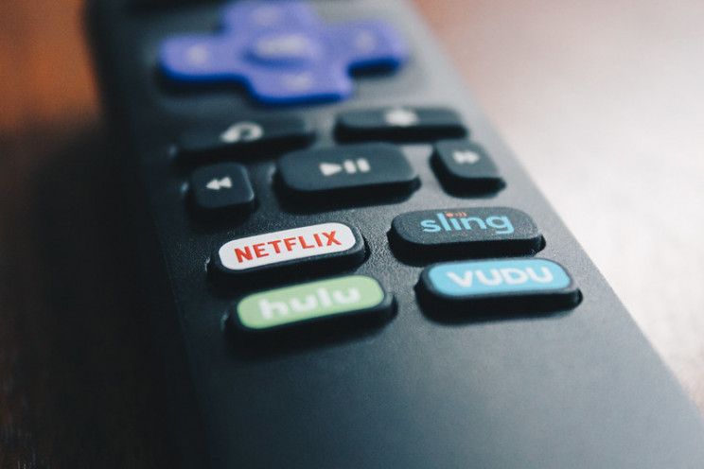*Source:* [*Stock Catalog/Flickr*](https://www.flickr.com/photos/stockcatalog/40062279010/in/photolist-243aDNs-2iXWLQ1-74R6y5-Luodqo-CzNPJs-24m3oZ-7pCcqg-2a3TCG-7yekZL-62vaeJ-7vRHoA-a3C7gC-9A6sey-JY2k2t-7NuHd7-5Tcn5R-6dfH1v-KPmL1R-9pmoxi-94mDyX-7kB4jP-4m7k6S-89y75X-4bWtke-9vou6m-5RFMJn-Bufki-23voJ5o-7vRVVJ-2cAes8y-JNRRk5-9dXzoE-7Aq39p-QXkmTe-8NSauQ-9kvo32-motajk-E3wTU-qQbzL-sr2a7-awabqC-qQbs6-9js3Yg-qQbvU-qQbkd-qQbED-qQbDq-24Hi45F-qQboD-7hiJ13)

**2014 sees Netflix's continued expansion into Europe**

In 2014, Netflix launched in **6 new countries** in Europe (Austria, Belgium, France, Germany, Luxembourg, and Switzerland), and won **7 Creative Emmy Awards**. Netflix now had more than **50 million** members globally.

**Netflix expands into Australasia in 2015**

Netflix launches in Australia, New Zealand, and Japan, with continued expansion across Europe in Italy, Spain, and Portugal. The first Netflix original feature film “[Beasts of No Nation](https://www.nytimes.com/2015/10/16/movies/review-beasts-of-no-nation-a-brutal-tale-of-child-soldiers-in-africa.html)” is released.

Netflix also premieres its first non-English original series with the Mexican comedy "Club de Cuervos."

At the same time, Amazon "[Transparent](https://en.wikipedia.org/wiki/Transparent_(TV_series))*"* became the first show produced by [Amazon Studios](https://en.wikipedia.org/wiki/Amazon_Studios) to win a major award. Netflix was no longer the only streaming game in town.

**2016 is a big year for Netflix**

Netflix expands to another **130 countries** around the world, bringing its reach to a total of **190**countries. It also offers programming in **21 languages**.

They also unveil their ‘Download’ feature, which allows members to download TV shows and movies for offline viewing. Netflix continues to expand its collection of original international shows, with its first French series *"Marseille"*, first Brazilian series *"3%"*, and first non-English language original film, the Spanish drama *"7 Años."*

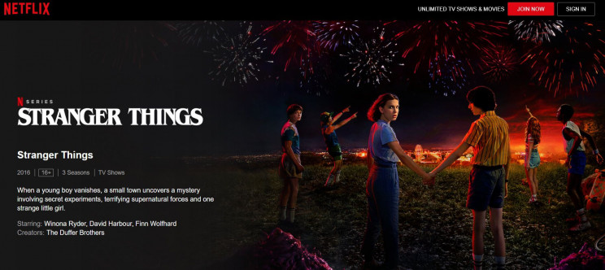*Source:* [*Netflix*](https://www.netflix.com/tr-en/title/80057281)

**2017 is another killer year for the company**

This is another good year for Netflix. They win their first Academy Award, for Best Documentary Short Subject for "The White Helmets".

At the same time, subscriber numbers reach an astounding **100 million** globally. Netflix also expands their international collection with the very popular series' "La Casa De Papel" (from Spain), "Suburra: Blood on Rome" (from Italy), and "Dark" (from Germany).

The year ends with a minor controversy, as [Netflix "calls out" users](https://interestingengineering.com/netflix-stirs-controversy-by-calling-out-53-users-whove-watched-a-film-repeatedly) who watch the same film multiple times. While done in jest, it also made users very aware that their watching habits were being monitored by the company, and sparked concerns over privacy.

This year, Amazon also began to make sports-related content acquisitions, acquiring non-exclusive rights to stream portions of the [NFL](https://en.wikipedia.org/wiki/National_Football_League)'s "[Thursday Night Football"](https://en.wikipedia.org/wiki/Thursday_Night_Football) games in a $50 million deal.

**Things get better and better for Netflix in 2018**

This year, Netflix wins more Academy Awards for its original content, including Best Documentary Feature for "Icarus."

2018 also sees Netflix's acquisition of the book publisher Millarworld, founded by the legendary comic book creator Mark Millar, in order to adapt company properties into films and TV shows.

In March, [Netflix employees launched a phone playing the original series "Star Trek: Discovery"](https://interestingengineering.com/video/netflix-sends-an-iphone-playing-star-trek-discovery-into-space) into space. This stunt was to celebrate the service now being available in more than **190** countries around the world.

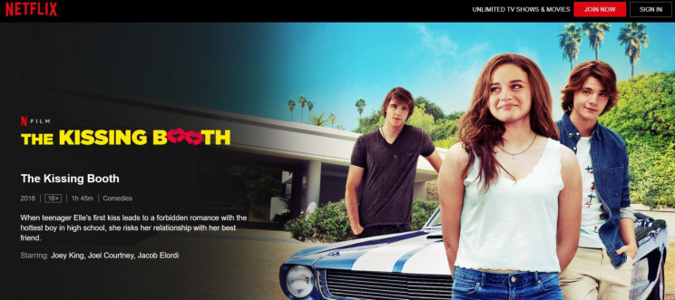*Source:* [*Netflix*](https://www.netflix.com/tr-en/title/80143556)

Netflix also becomes the most nominated service at this year's Primetime and Creative Arts Emmy Awards, receiving an amazing **112 nominations**. The company ties with the veteran HBO for most wins, taking home **23 accolades** for their series, including "GLOW," "Godless," "Queer Eye" and "Seven Seconds."

Amazon was coming up close behind, however, as the streaming service announced it had secured the UK rights to broadcast live [Premier League](https://en.wikipedia.org/wiki/Premier_League) football matches and purchased the global television adaptation rights to [*The Lord of the Rings*](https://en.wikipedia.org/wiki/The_Lord_of_the_Rings#Television), which will air on Prime Video.

**2019 sees more awards coming Netflix's way**

In 2019, Netflix wins four Academy Awards for Best Director, Best Foreign Language Film and Best Cinematography for "ROMA," and Best Documentary Short Subject for "Period. End of Sentence."

They also acquire the intellectual property rights for StoryBots, which was an Emmy, Annie, and Parents’ Choice award-winning children’s media brand created by Gregg and Evan Spiridellis. Netflix also releases "Klaus", its first-ever original animated feature film.

2019 also sees the release of "[Inside Bill's Brain](https://interestingengineering.com/want-to-get-inside-bill-gates-head-netflix-has-you-covered)", a three-part documentary covering the life and times of the man behind Microsoft. It is an instant hit. [Netflix and Tesla](https://interestingengineering.com/youtube-and-netflix-will-soon-be-coming-to-teslas-screens-says-elon-musk) also confirm that the streaming service will be available on Tesla screens very soon.

Netflix unveils its first international original films from the Middle East ("Jinn") and Thailand ("The Stranded"). This year, Netflix wins **27** Primetime and Creative Arts Emmy Awards for series including "Black Mirror: Bandersnatch," "Ozark," "Queer Eye", and "When They See Us."

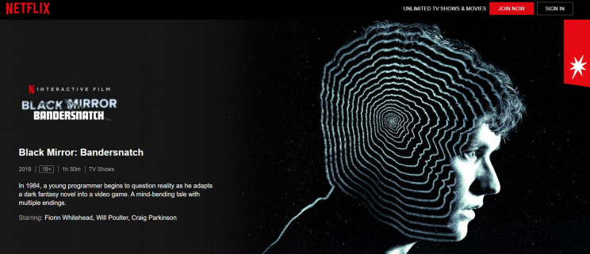*Source:* [*Netflix*](https://www.netflix.com/tr-en/title/80988062)

However, not everything is rosy for the company. Inspired by their success, a  number of [other companies begin to get in on the act](https://www.thestreet.com/technology/history-of-netflix-15091518) by starting, or expanding, their own streaming services.

Disney, AT&T, and Apple all launch their own Netflix alternatives in 2019. When Disney+ made its debut the following year, it meant the end of Disney blockbusters, such as the Star Wars films, being available on other streaming services.

**Will 2020 be another bumper year for Netflix?**

To date, Netflix's subscriber base has grown to well over **180 million**, with **70 million** or so from the United States alone.

**What does the future have in store for Netflix?**

Many experts believe that the future could look less rosy for Netflix. This is, in part, because of the explosion in other streaming services launched to challenge Netflix's seeming dominance.

Netflix, to its credit, appears to have predicted the impending threat several years ago, as it acknowledged that major media conglomerates would start to pull their content from Netflix to add to their own services.

*Source: [scanrail/iStock](https://www.istockphoto.com/photo/streaming-media-technology-and-multimedia-concept-gm1054956016-281867973" \t "_blank)*

"This is why, in 2018, Netflix spent **$12 billion** building its library of original films and series, an **88%** uptick from 2017. And, spend on original content this year is expected to reach **$15 billion**. The strategy was to backfill its library with original content to gain and retain subscribers," according to [Forbes](https://www.forbes.com/sites/danafeldman/2019/07/15/the-future-of-netflix-is-it-really-as-doom-and-gloom-as-people-are-saying/#307d34446682).

Based on this, it seems Netflix will continue to focus on its own content going forward, rather than relying on potential streaming competitors not pulling their content from the platform.

Another option is for Netflix to move to an advertisement-based system in the future. However, up to this point the company has been **staunchly opposed** to this.

Netflix has weathered many storms before and it would foolish to believe it is not nimble enough to do so going forward.